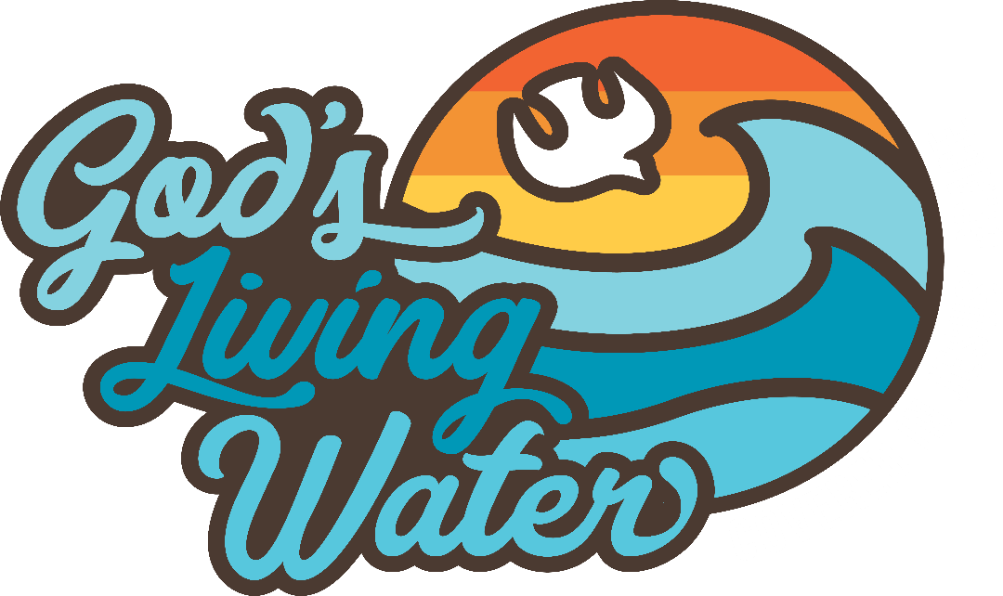

VACATION BIBLE SCHOOL
Coming to Emanuel Lutheran Church, Friesburg
July 24-27, 2023
5:30 p.m. – 8:00 p.m.
Each evening includes: Dinner, Story, Craft, Science station, Music and other surprises
Ages 3 and up, including adults are welcome.

https://vbsmate.com/events/EmanuelElmerNJ/27650

